Emilie Mediz-Pelikan (Vöcklabruck 1861-1908 Dresden)  A triple portrait of Hermine, Emilia and Helena  Signed and dated (lower right): ‘1897. E. PELIKAN’; inscribed (lower right): ‘JULIE GOTTSCHE’ and (centre) ‘HERMINE EMILIA HELENA’  Pencil and coloured crayon  17¾ x 26¼ in. (45.5 x 67cm.) | 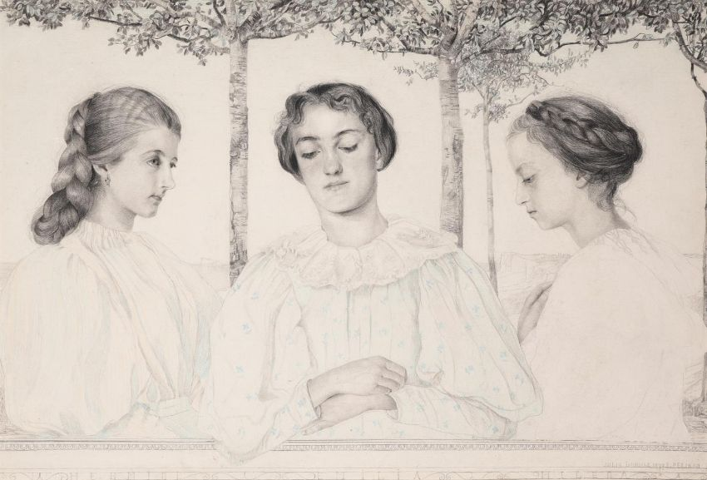

Provenance
The Estate of the late David Fyfe-Jamieson.

Emilie Mediz-Pelikan (nee Pelikan) was a student of Albert August Zimmermann at the Academy of Fine Arts in Vienna, and she followed him when he was appointed professor in Salzburg and later in Munich. In 1888, following Zimmerman's death, she moved to the artist's colony in Dachau, outside Munich, where she formed a close relationship with the painter and head of the colony, Adolf Hölzel. Amongst the other artists was the younger Viennese painter, Karl Mediz. Around this time, she spent a while in Paris studying the Impressionists. Her first gallery exhibition was held in 1890 by which time she was living in Knokke, Belgium, where she met Mediz again. The two were married in Vienna in 1891, moving to Krems an der Donau where their daughter Gertrude was born. Success, however, was very hard to come by and they settled in Dresden in 1894. Stephen Ongpin, in his online notes for a work by Emilie Mediz-Pelikan, wrote, 'In one of the only contemporary accounts of their work to be published in English, the British-Austrian art historian Amelia Sarah Levetus, who must have known the couple, wrote that 'These two artists are man and wife; they have wandered in many places together, over the highest mountains and across glaciers, on the banks of deep rivers and on their pilgrimages have painted scenery and portraits and everything else between. They have endured the greatest hardships together and have worked together; they have chosen the same subjects for their canvases, yet their individualities remain, and in similar subjects also there is a great variety of treatment...Frau Mediz-Pelikan also has immense energy, combined with poetry of expression more delicate than that of her husband; she loves to paint lavenders and silver greys, to bring out the very depths of that which she is depicting.' Both Emilie and Karl were invited, in 1898, to show three pictures each at the inaugural Vienna Secession exhibition. Whilst her early work showed the influence of her interest in Impressionism, fostered during her stay in Paris, her next phase showed a Symbolist quality, particularly in the power of nature. In 1901 three oils by Mediz-Pelikan were included in the Internationale Kunstausstellung in Dresden, (Harmonie in violette, Orangenbaum and Oliven). These oils were shown alongside works by, amongst others, Charles Rennie Mackintosh, Anders Zorn, Whistler, Lucien Pissarro, Toulouse-Lautrec, and GF Watts. Two years later a joint exhibition of works by Karl Mediz and Emilie Mediz-Pelikan, including twenty-four paintings and sixteen drawings by the latter, was held at the Hagenbund, the Austrian artist’s association in Vienna. At the February 1903 exhibition her painting Bluehender Kastanienbaum was acquired by the state for the newly-established Moderne Galerie at the Lower Belvedere in Vienna, which opened to the public three months later. (Mediz-Pelikan was eventually made an honorary member of the Hagenbund, which did not formally accept women until 1924.) In 1904 an exhibition of Emilie’s graphic work took place at a gallery in Dresden, and in 1905 and 1906 her paintings were shown at the Künstlerhaus in Berlin. As Amelia Levetus, writing in 1905, noted of Emilie Mediz-Pelikan and Karl Mediz, ‘In personal appearance these two are as different as their works; in nature they are one; he considers her the greater artst and she him…Both Herr and Frau Mediz look for new ground and out-of-the-way corners for work. They are both so fond of rich colouring that they seek those parts of the earth where Nature is most profuse in her gifts. They have both endured the blaze of the sun on the highest points of the Dolomites and other ranges of the South Tyrolean mountains, often spending days on their heights, at different periods of the year, with no one near, and sleeping under the blue canopy of heaven. In their open-air existence they have learned the true shades of the rays of the sun as they fall upon earth; and so they know full well all the tones from orange to violet, and from violet to orange...Both husband and wife are fond of their combinations of colours, greens, reds and greys...Of the two, Frau Mediz has the wider field. She has more tones and nuances, more delicacy and more variety…She is influenced by him, and also has nocturnes in blue and silver, such as Whistler might have painted…These two, both husband and wife, have a great future before them.’

Sadly, however, this was not to be. Emilie Mediz-Pelikan died suddenly of a heart attack in 1908, at the age of forty-seven. Her husband was devastated by the loss, and became something of a recluse, creating mainly graphic works and only a few paintings. His career never recovered before his death thirty-eight years later, in 1945. Although the estate of both Emilie Mediz-Pelikan and Karl Mediz was administered by the Staatliche Kunstsammlungen in Dresden, the couple’s daughter Gertrude refused to allow any exhibitions of their work to take place. The estates passed into the ownership of the East German state, and both artists fell into obscurity. Mediz-Pelikan’s paintings and drawings were eventually returned to Austria, and much of the estate was acquired by the Viennese art dealer Kurt Kalb. Although a small exhibition of her work was held in Linz in 1986, it has only been in the past two decades that Mediz-Pelikan’s oeuvre has been truly rediscovered and her posthumous reputation as a gifted landscape artist and draughtsman secured. In 2019 Emilie Mediz-Pelikan was among the artists included in the revelatory exhibition City of Women: Female Artists in Vienna 1900-1938, at the Österreichische Galerie Belvedere in Vienna, which today owns four paintings by the artist.

David Fyfe-Jamieson (1954-2020) was educated at Radley College where he was a celebrated cricketer. With his great friend Henry Wyndham, later chair of Sotheby's in London, he enrolled at the Sorbonne to learn French. Neither finished the course, spending more time eating out and watching Marx Brothers films. After a short spell in Australia, David went to South Africa where he worked for Wildenstein, eventually returning to London where he joined the Old Master Paintings Department of Sotheby's. He subsequently worked for Artemis Fine Art, a leading Old Master Art Consultancy. He eventually set up on his own in Dover Street, London, but closed it in 2000. He went on to reinvent himself as a cabinet maker in Shropshire, where he lived until he died last year.

